CSE486.1
Quiz1
Ahadul Islam
1811386042
Submitted to: SAS3

https://github.com/NSU-SU21-CSE486-1/1811386_SU21_CSE486_1/tree/main/Project/Version02/quiz2

The project is made using java programming language and XML.

It is a very simple program . It open with taking four inputs from the user
Name, Date of Birth,NID,Blood Group. I implement a new layout called tab layout
Which has three items Basic University Affiliation and Numbers .
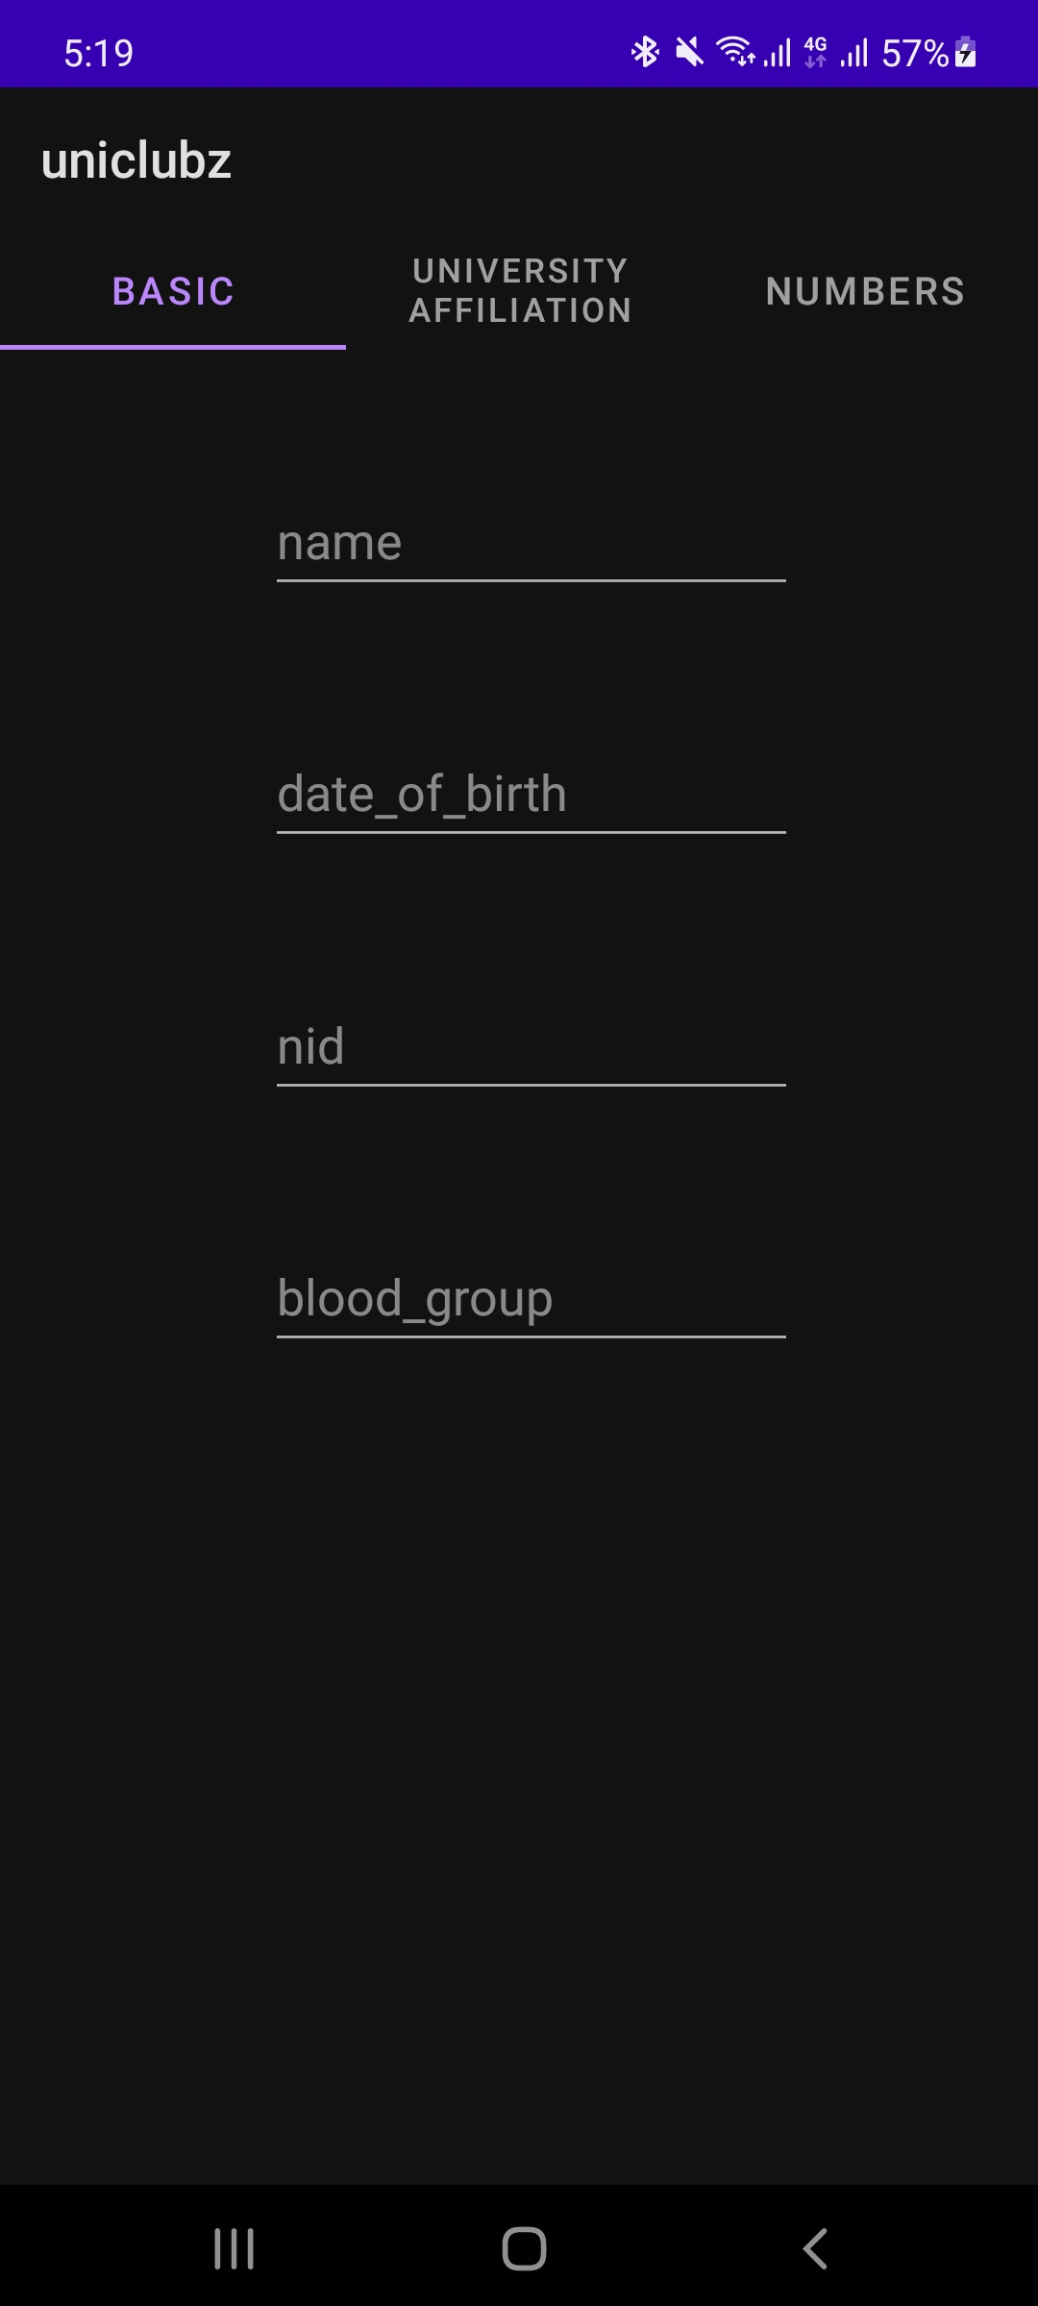

The University Affiliation is able to take multiple entries. The entries are taken in multiple small fragments and can add upto three fragments which appear on a click of a FAB.
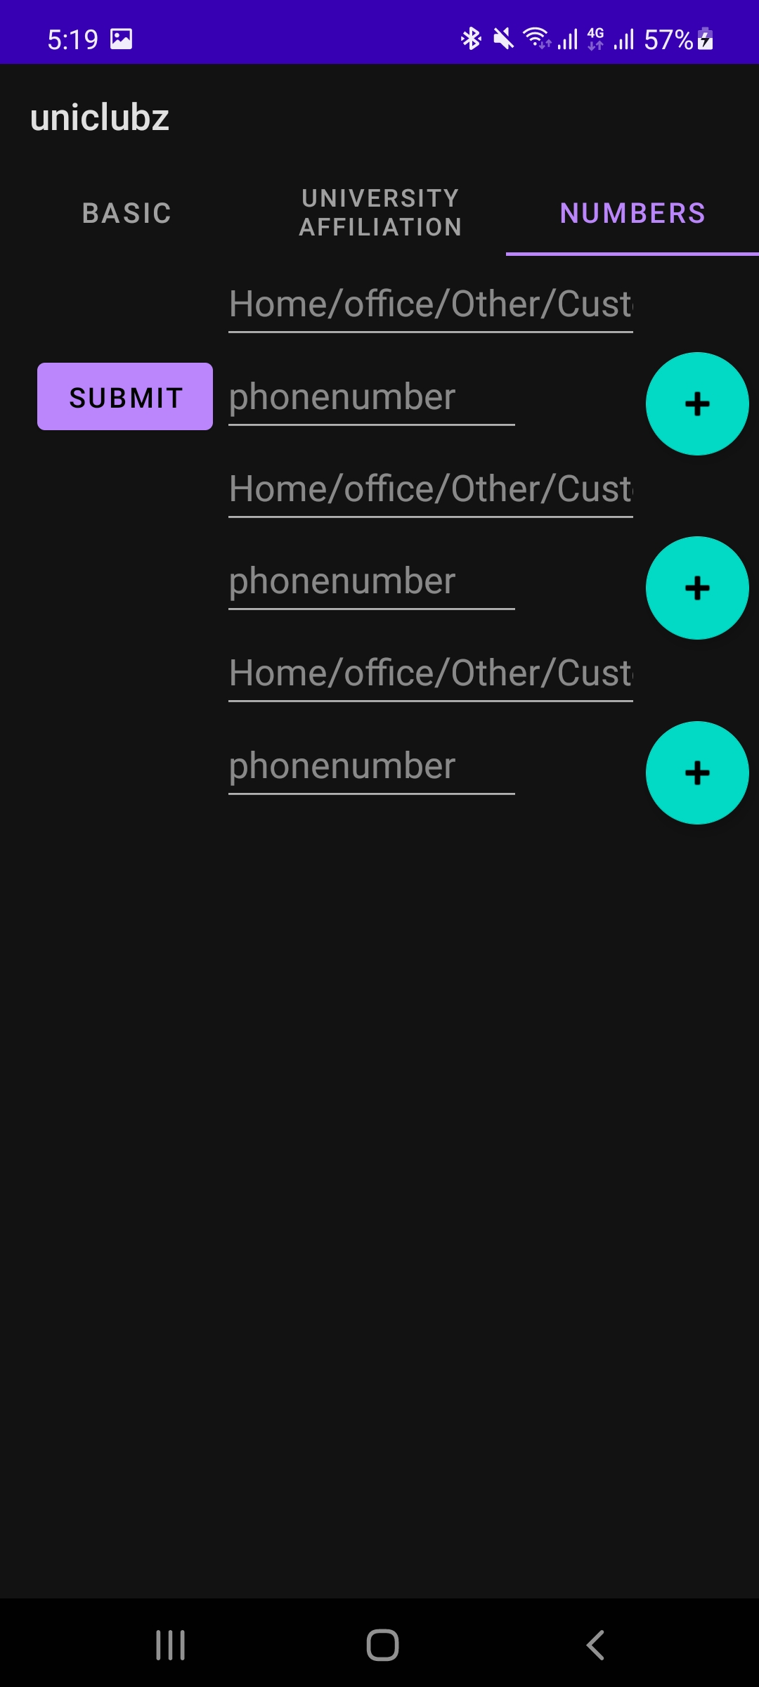

The thrid tab item has also able to take multiple phone numbers as well.

On the clicking the submit button the information is supposed to carried over the a recycleer view and be displayed.
.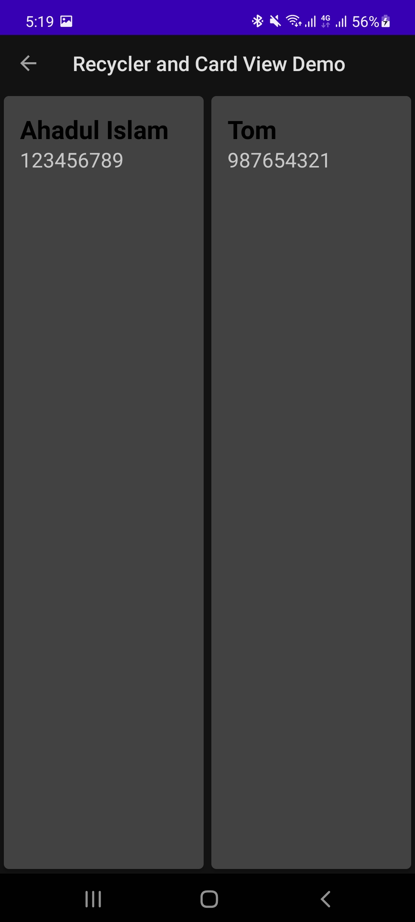
When we click in user name the rest of the information is supposed to show up. 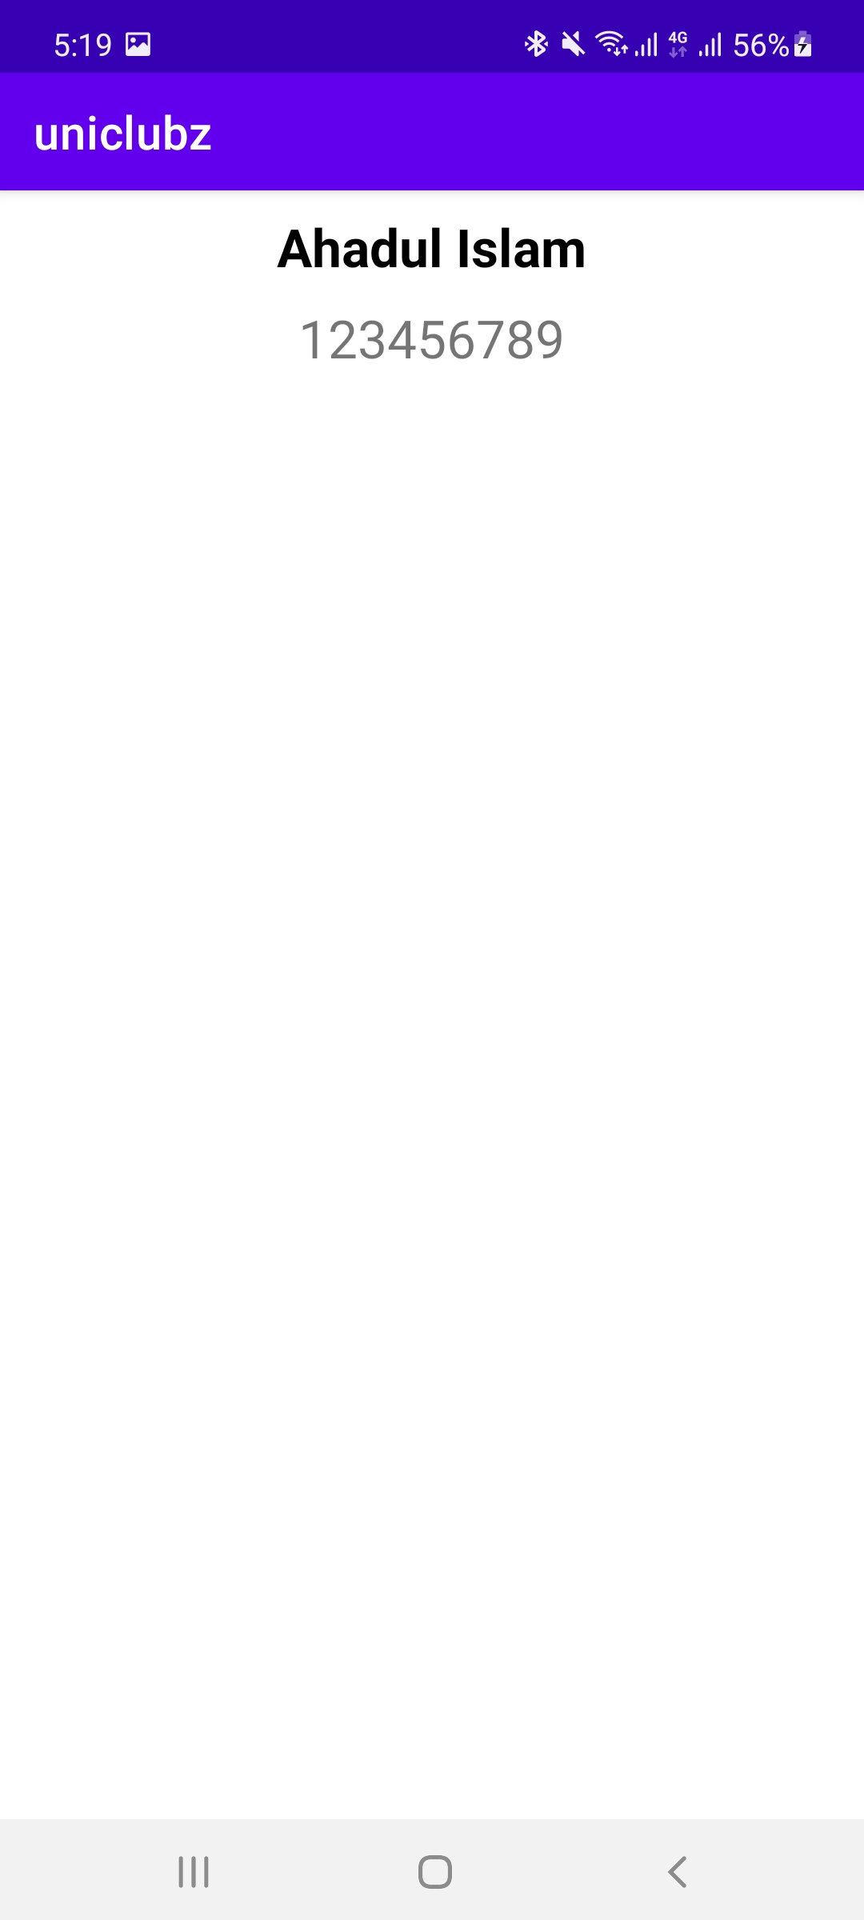

I was unable to use serialization and parcel-able to transfer information through the recycler view and the two examples are hardcoded.

